**Computer Hardware Experiments**

Lab_01: Basic operation of ALU

**Name : 李泽宇 Student_ID: 1709853W-I011-0036**

Part 1：Design a one bit full adder

1.source code:

—————————————————————————————library IEEE;

use IEEE.STD_LOGIC_1164.ALL;

-- Uncomment the following library declaration if using

-- arithmetic functions with Signed or Unsigned values

--use IEEE.NUMERIC_STD.ALL;

-- Uncomment the following library declaration if instantiating

-- any Xilinx primitives in this code.

--library UNISIM;

--use UNISIM.VComponents.all;

entity adder is

Port ( A : in STD_LOGIC;

B : in STD_LOGIC;

Ci : in STD_LOGIC;

S : out STD_LOGIC;

Co : out STD_LOGIC);

end adder;

architecture Behavioral of adder is

begin

S <= A xor B xor Ci;

Co <= (A and B) or (Ci and (A xor B));

end Behavioral;

1. simulation waveform：

A.

ISim > restart

ISim > put A 0

ISim > put B 1

ISim > put Cin 1

ISim > run 10ns

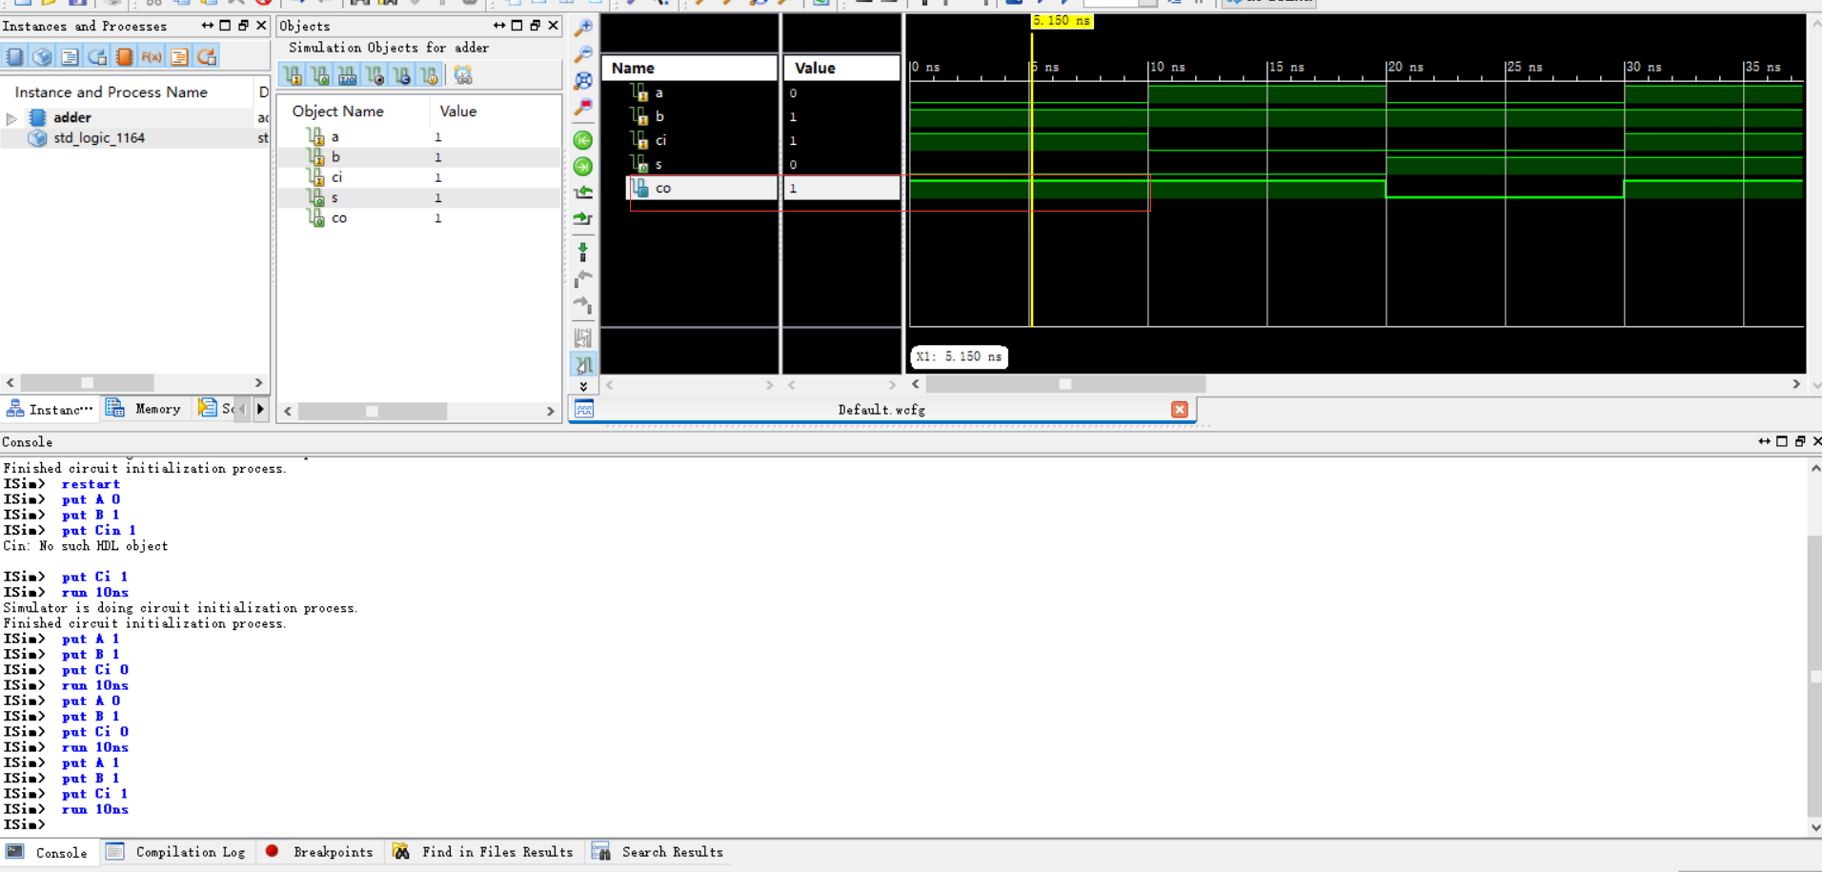

B.

ISim > put A 1

ISim > put B 1

ISim > put Cin 0

ISim > run 10ns

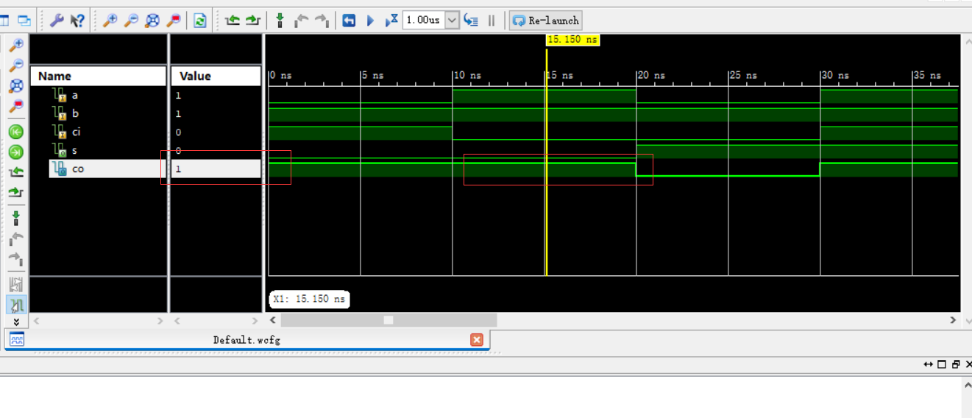

C.

ISim > put A 0

ISim > put B 1

ISim > put Cin 0

ISim > run 10ns

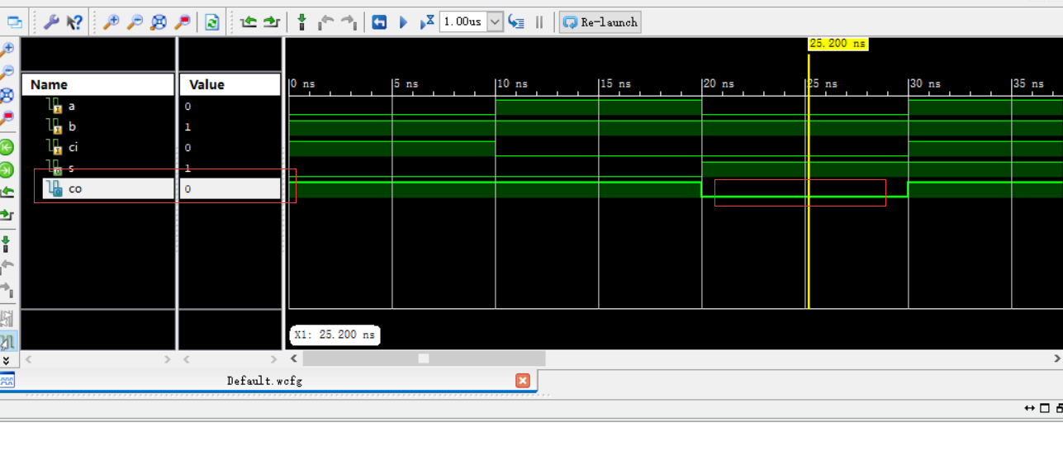

D.ISim > put A 1

ISim > put B 1

ISim > put Cin 1

ISim > run 10ns

ISim >

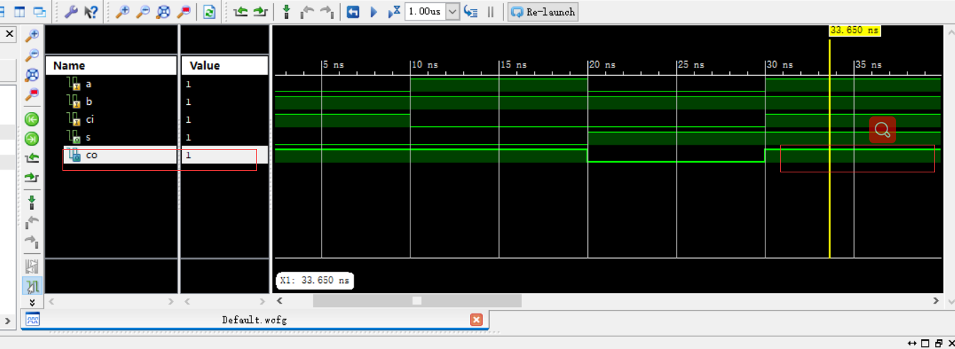

Part2：Design a 16 bit Multiplier.

1.source code:

library ieee;

use ieee.std_logic_1164.all;

use ieee.std_logic_arith.all;

use ieee.std_logic_unsigned.all;

-- Uncomment the following library declaration if using

-- arithmetic functions with Signed or Unsigned values

--use IEEE.NUMERIC_STD.ALL;

-- Uncomment the following library declaration if instantiating

-- any Xilinx primitives in this code.

--library UNISIM;

--use UNISIM.VComponents.all;

entity multiplier is

Port ( A : in STD_LOGIC_VECTOR (15 downto 0);

B : in STD_LOGIC_VECTOR (15 downto 0);

P : out STD_LOGIC_VECTOR (31 downto 0));

end multiplier;

architecture Behavioral of multiplier is

begin

P <= A * B;

end Behavioral;

2.simulation waveform：

A.

ISim > restart

ISim > put A 5 –radix dec

ISim > put B 6 –radix dec

ISim > run 10ns

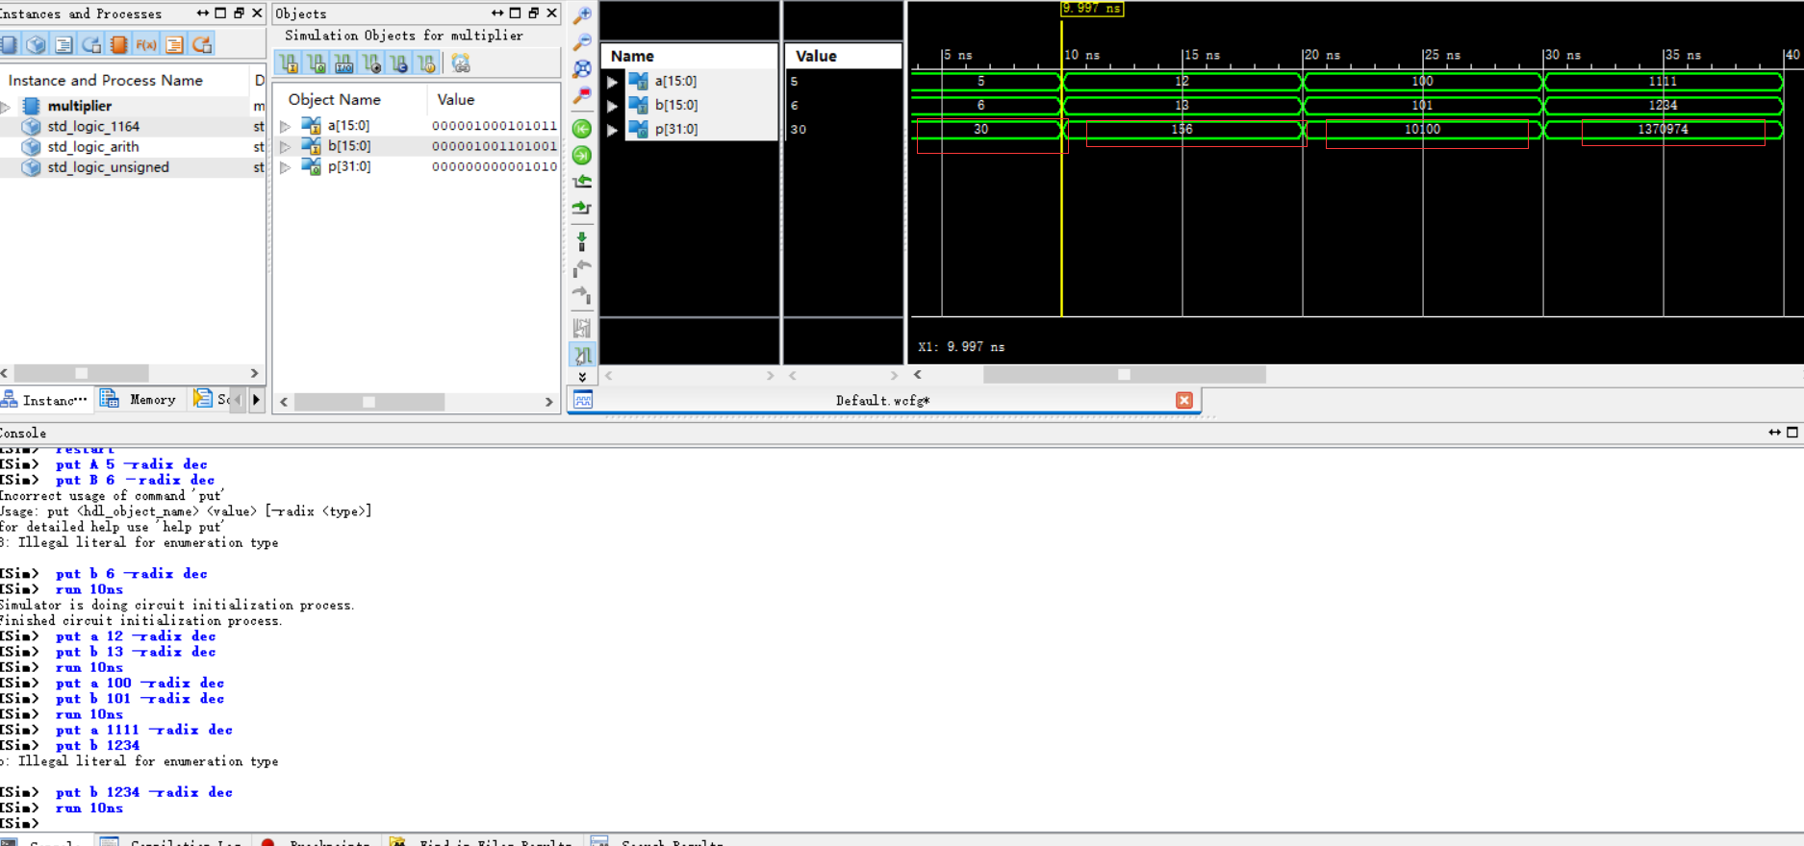

B.

ISim > put A 12 –radix dec

ISim > put B 13 –radix dec

ISim > run 10ns

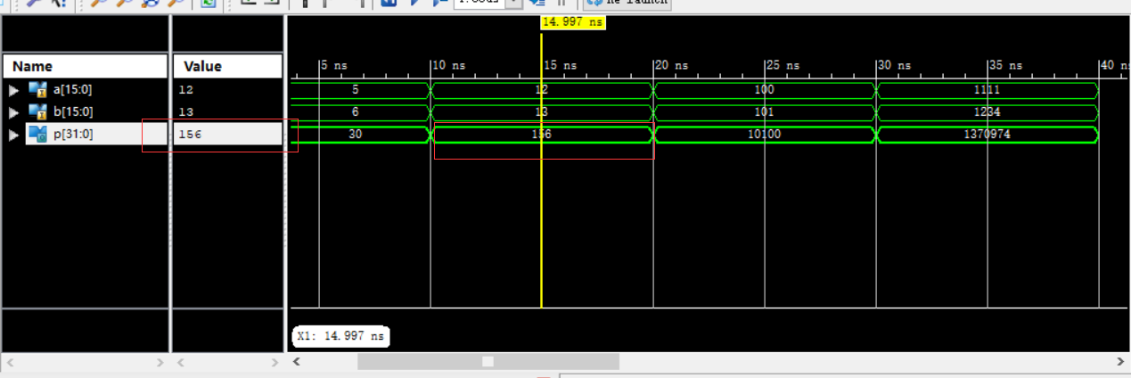

C.

ISim > put A 100 –radix dec

ISim > put B 101 –radix dec

ISim > run 10ns

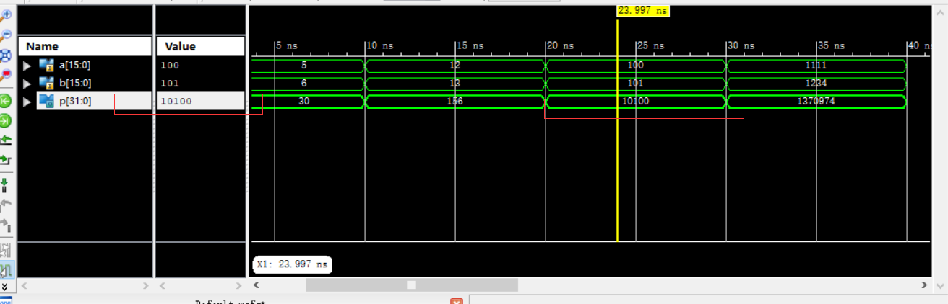

D.

ISim > put A 1111 –radix dec

ISim > put B 1234 –radix dec

ISim > run 10ns

ISim >

